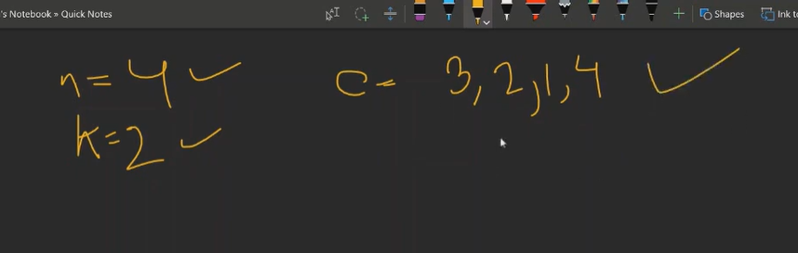

See we need to find min and max according to the logic hence we will need to sort this.

Code:

